

**PROJECT**

**“Donate.Id”**

Name :

Fitriani Chaerunisa 1820010077

Thalia Azzahra Maharani 1820010209

Class: 4SC6

Faculty : Mr. Fachran Nazarullah, S.Kom

**Continuing Education Program Center for Computing and Information Technology**

* + 1. **Faculty of Engineering, University of Indonesia**

PROJECT ON

Donate.Id

Developed By

Name : Fitriani Chaerunisa 1820010077

Thalia Azzahra Maharani 1820010209

NIIT

Donate.Id

Batch Code : 4SC6

Start Date : 3th April, 2020

End Date : 6th May, 2020

Name of The Coordinator : Mr. Fachran Nazarullah, S.Kom

Name of Developer : Fitriani Chaerunisa

Thalia Azzahra Maharani

Date of Submission : 8nd May, 2020

NIIT

Certificate

This is to certify that this report titled “Donate.Id”, embodies the original work done by Fitriani Chaerunisa and Thalia Azzahra Maharani in partial fulfillment of their course requirement at NIIT.

Coordinator:

Mr. Fachran Nazarullah, S.Kom

Acknowledgement

Thanks to God who has given the for giving us blessings, health, quota internet, ability to be able to finish this Project with the title “Donate.Id”, without any of it I won’t be able to complete it right on time. Despite many hurdles and obstacles that we experienced in the course of the work, but I managed to finish it properly. We also who have guided and have benefited a lot from the feedback and suggestions given to us in completing this project especially Mr. Fachran Nazarullah, S.Kom.

In arranging this project, the writer truly get lots challenges and obstructions but with help of many individuals who can’t be mentioned one by one, those obstructions could have passed. writer also realized there are still many mistakes in process of writing this paper. This paper may have some flaws and imperfections, we hope readers will give comments and suggestions.

Depok, March 2020

System Analysis

Donate.id is web that build with HTML5, CSS, Bootstrap, JavaScript, and JSON. This Website have a function to donate, monitor, and create the fundaiser on that website.

**Home Page**

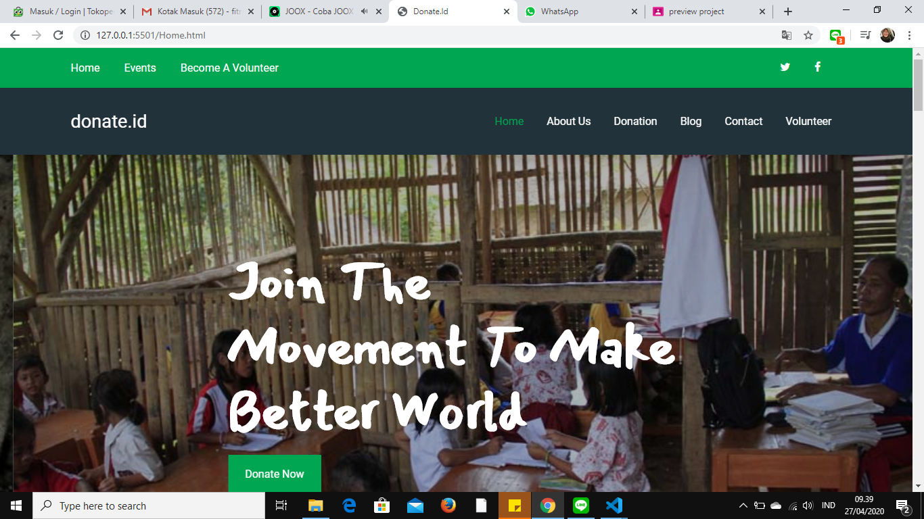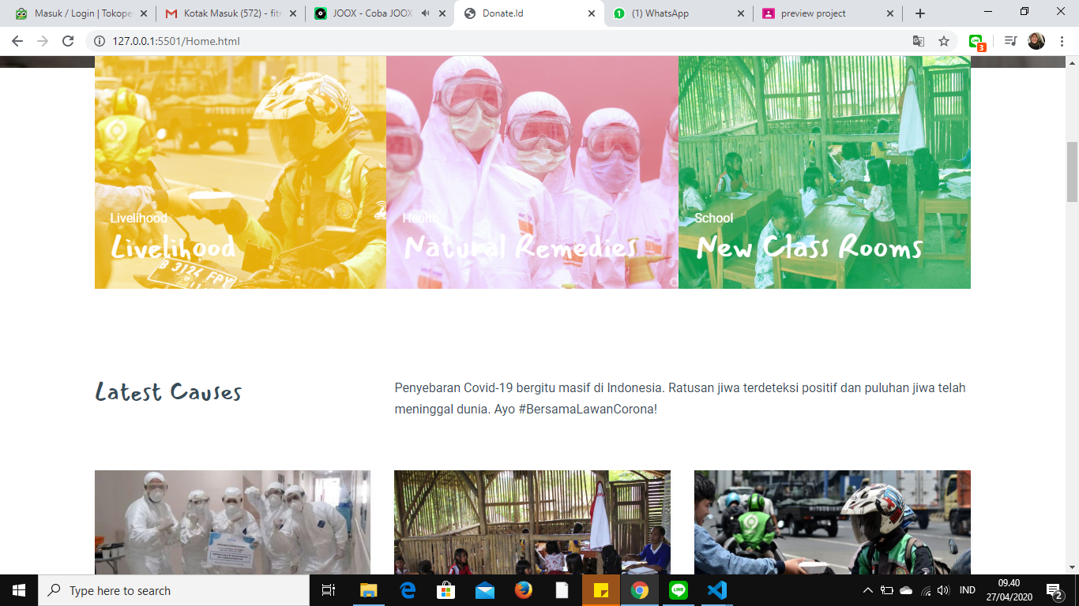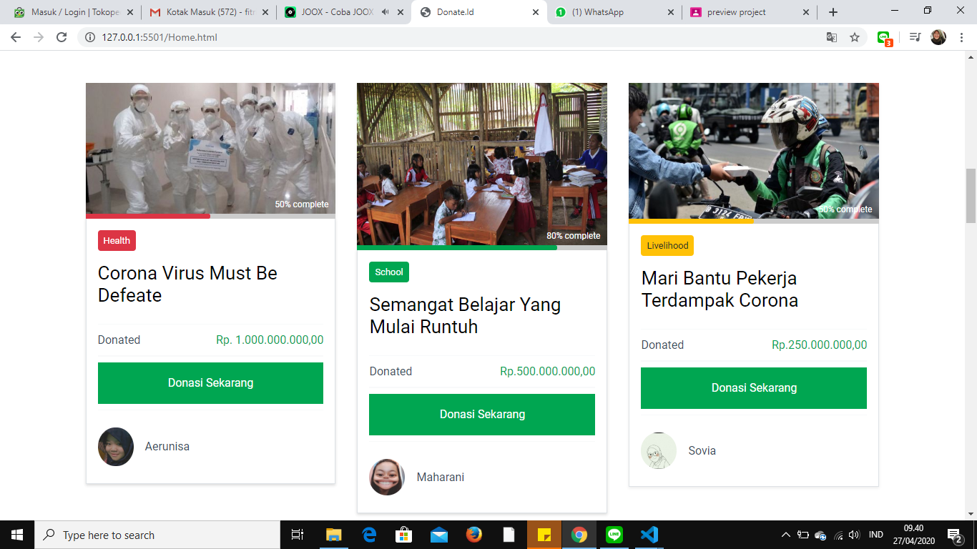

**Home Page**

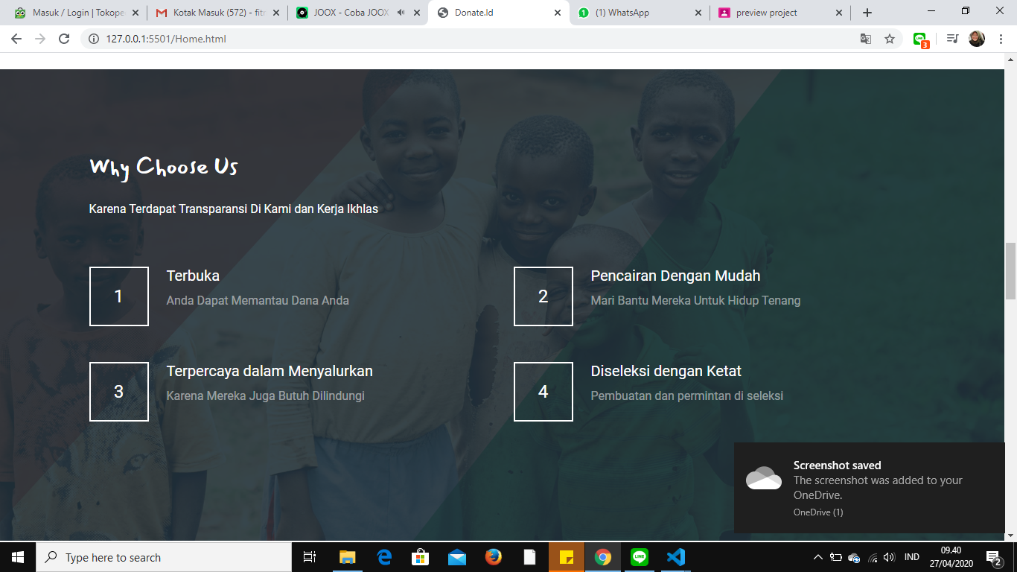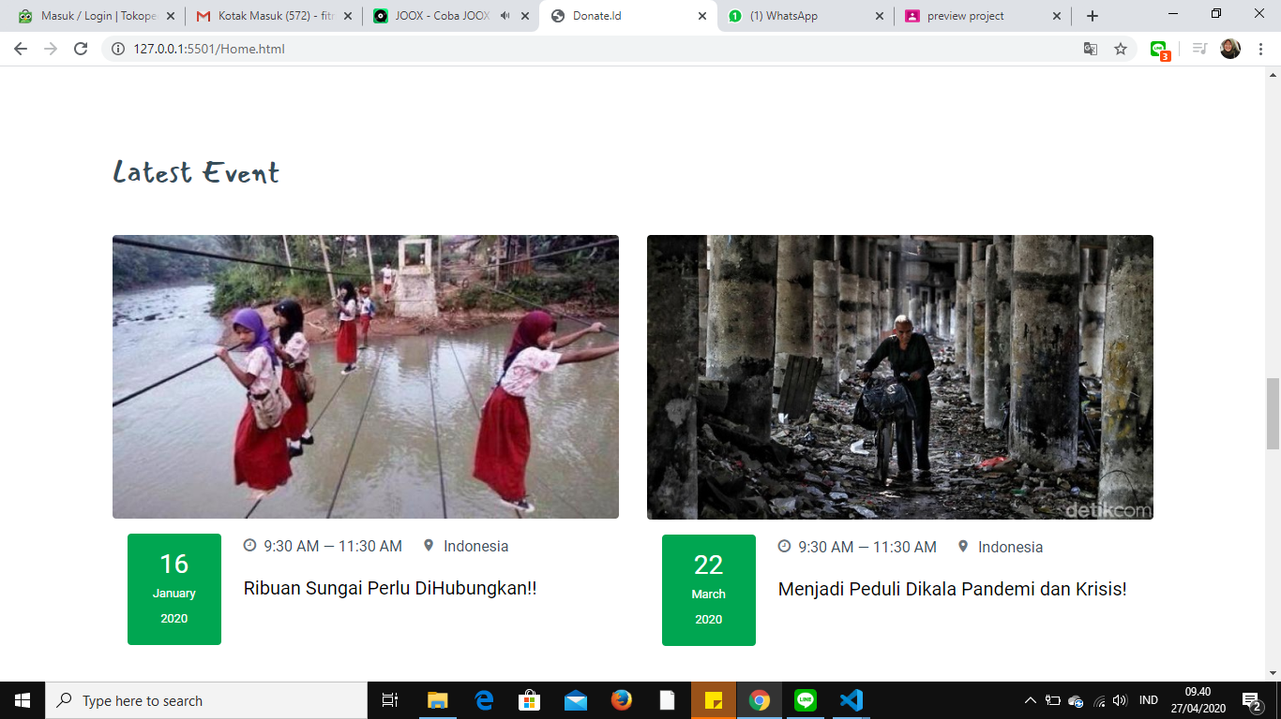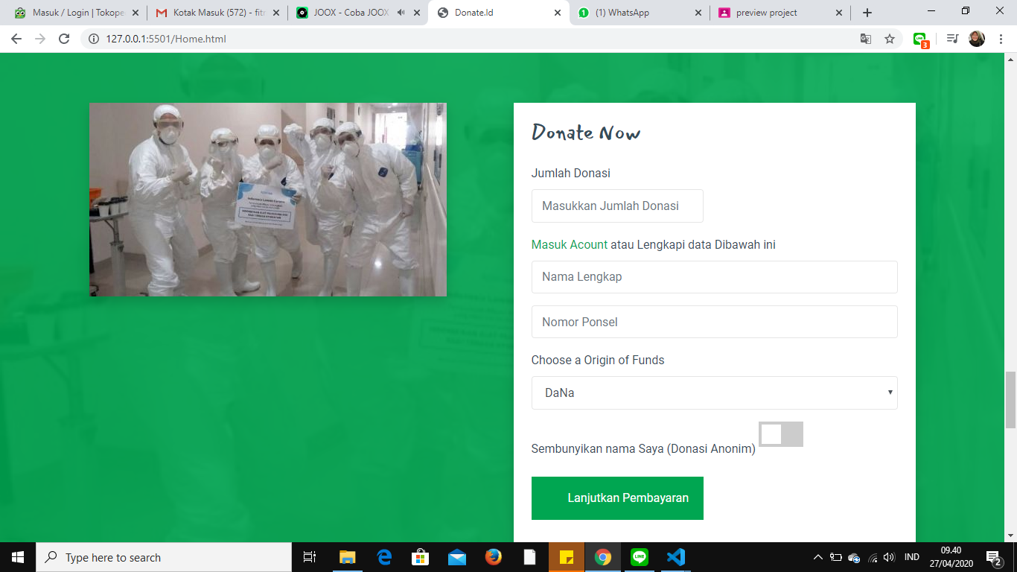

**Home Page**

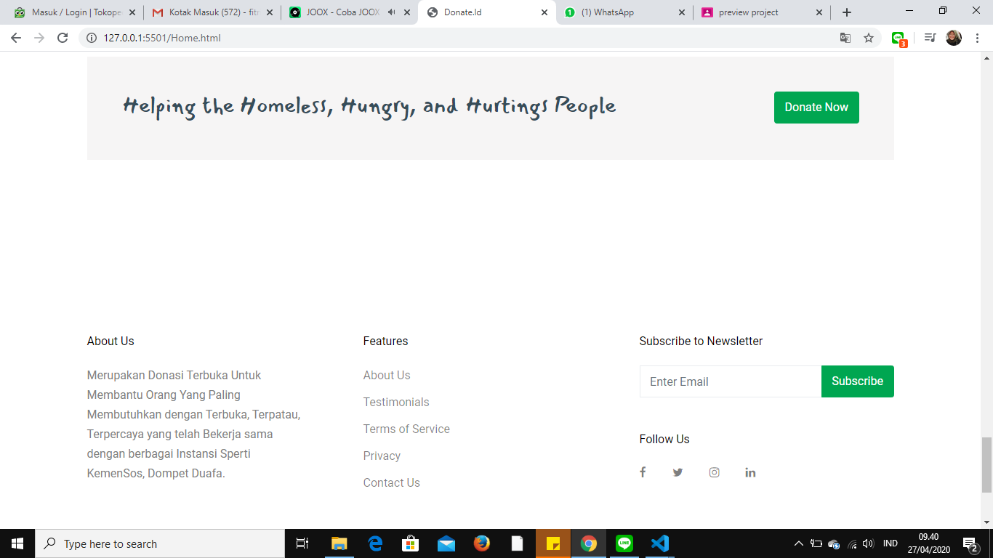

On the Home Page I present above there are 2 navbar whose purpose is to navigate to the page as the name implies. then after the Navbar we show a slide image with Text and a donate button that directs to the Corona / Urgent Donation node. then underneath we serve kass - kass with the donate button and information from the collection of funds, the user can click the donation button to directly donate or click on the picture to read the case and see the development of the case from the isiblog page. then underneath there are several blogs and donations directly on the page. after that we made a footer like in the picture.

**About Us Page**

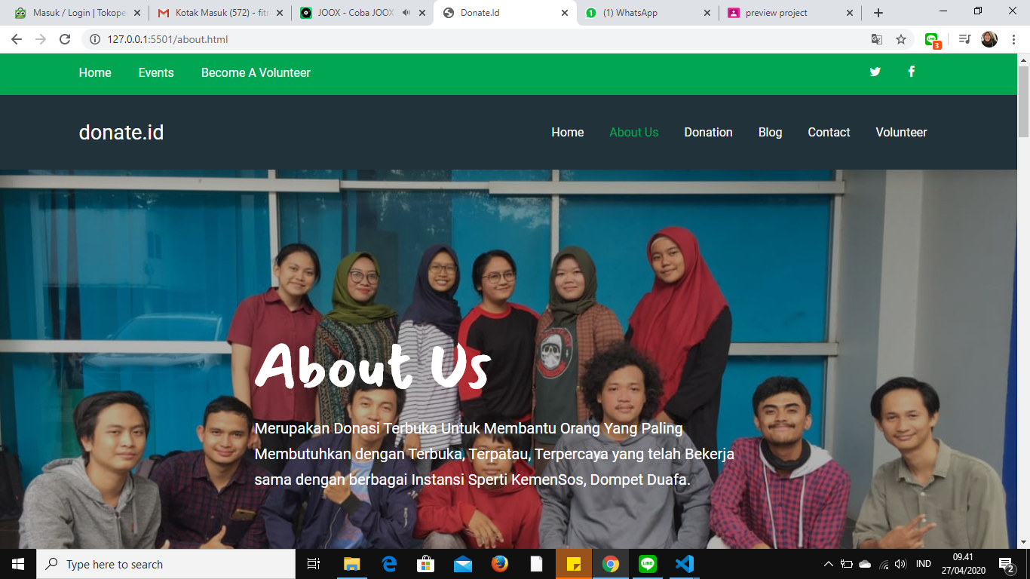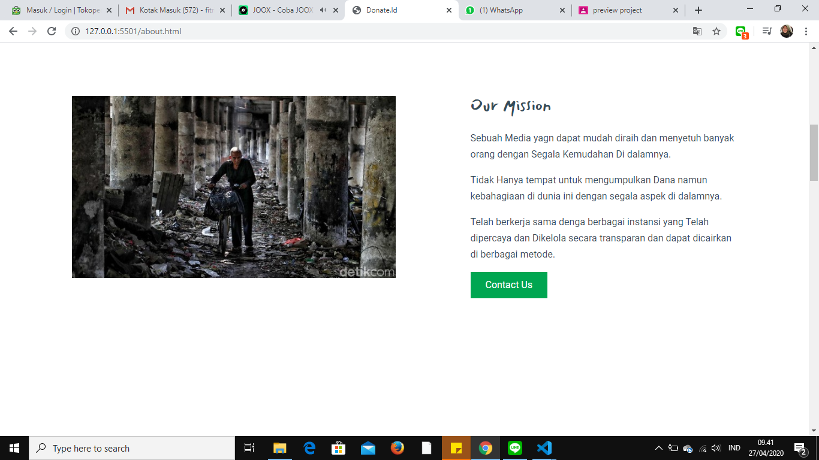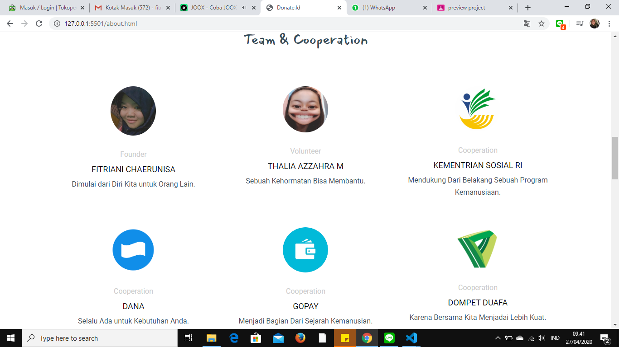

**AboutUs Page**

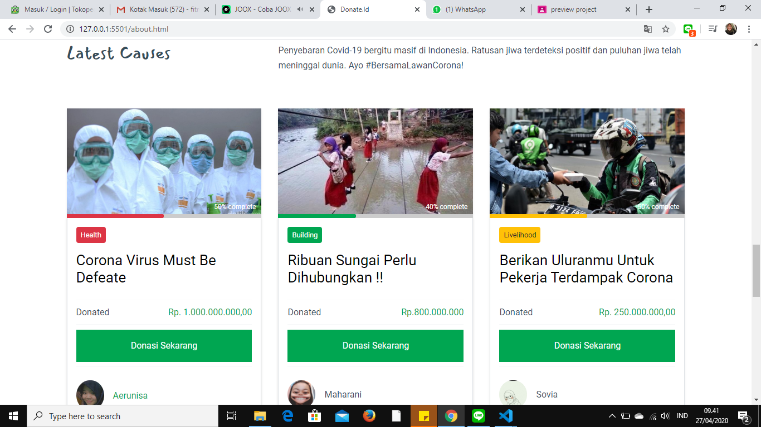



On the About Us Page, I present information about our team with the same appearance as HomePage, which includes Navbar, Text, Profile picture from the team, and certainly not forgetting some cases of fundraising and footers.

**Causes/Donation Page**

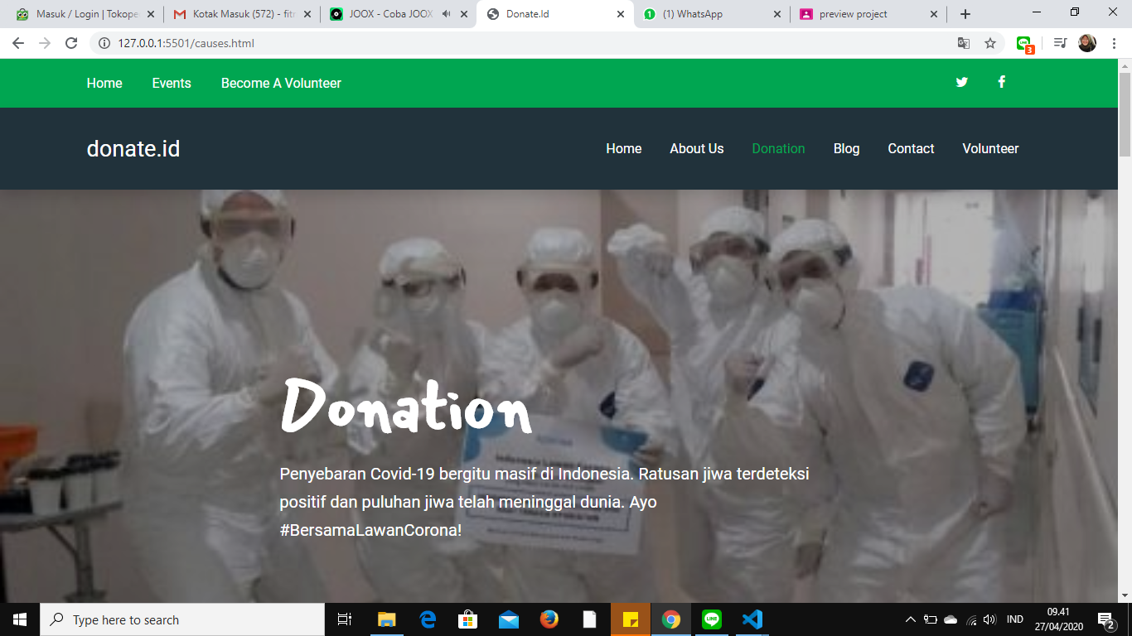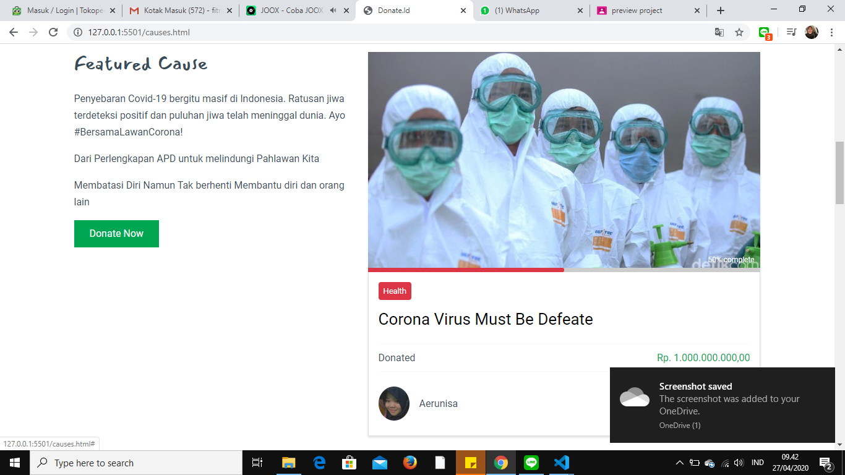

**Causes/Donation Page**

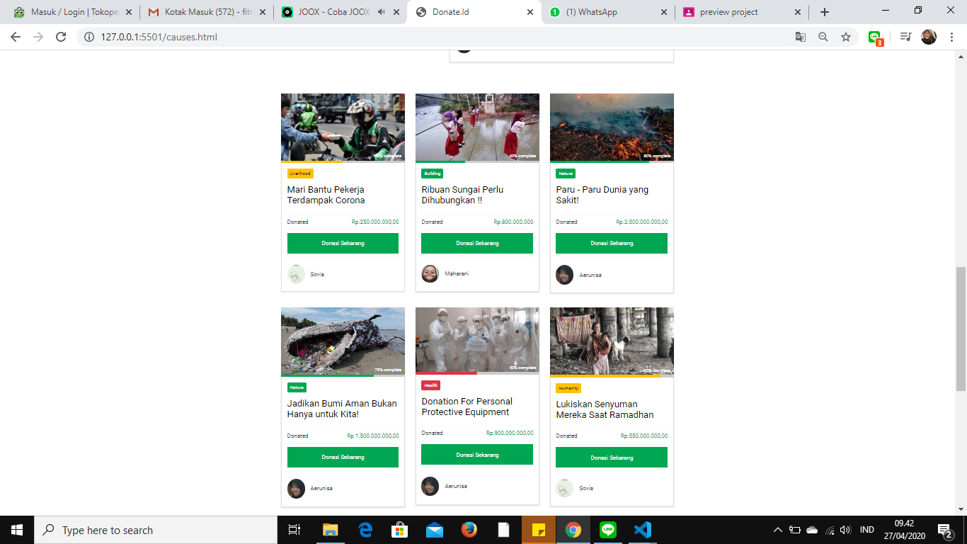



Ok On the Donation page / cause I made it a page that functions as all sorting donations. on this page I use json to store all the donations that have been made the same as the other pages.

**Blog Page**

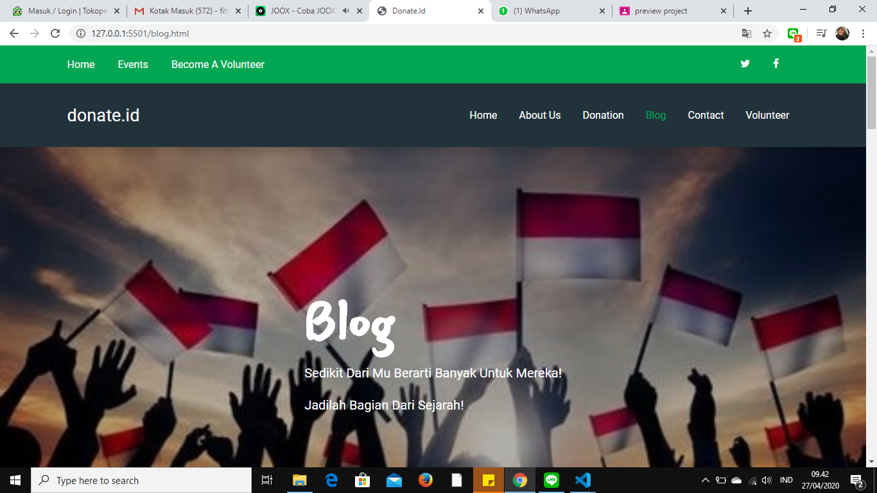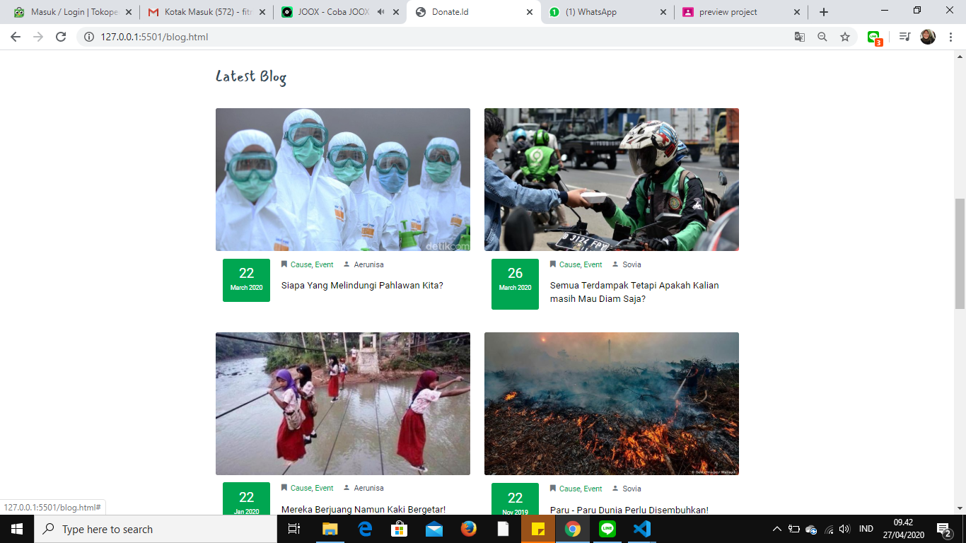

On the Blog page intended for users to read the donated case, by clicking on an image or writing from one of the cases will bring the user to the contents of the Blog. I made the rest like the other pages.

**IsiBlog Page**

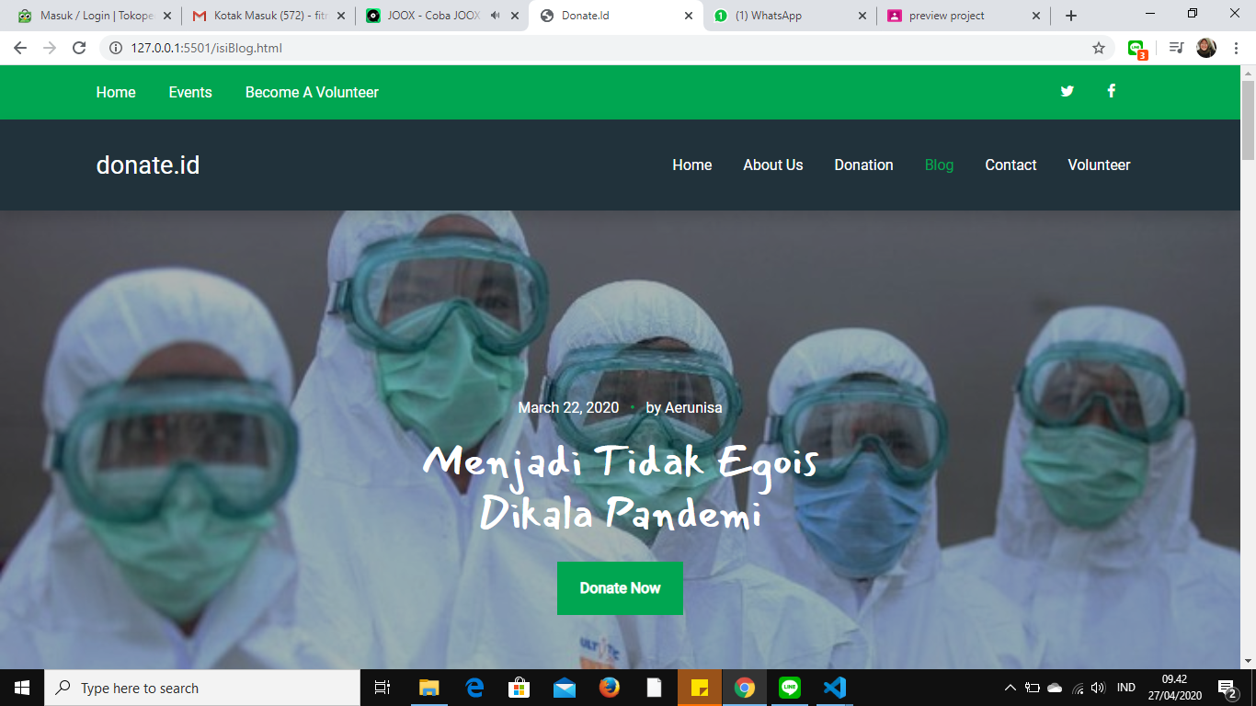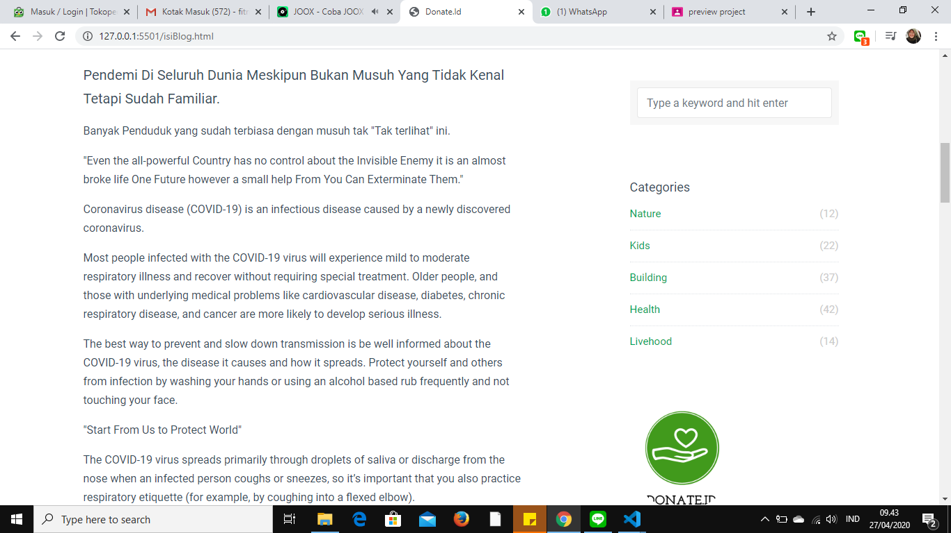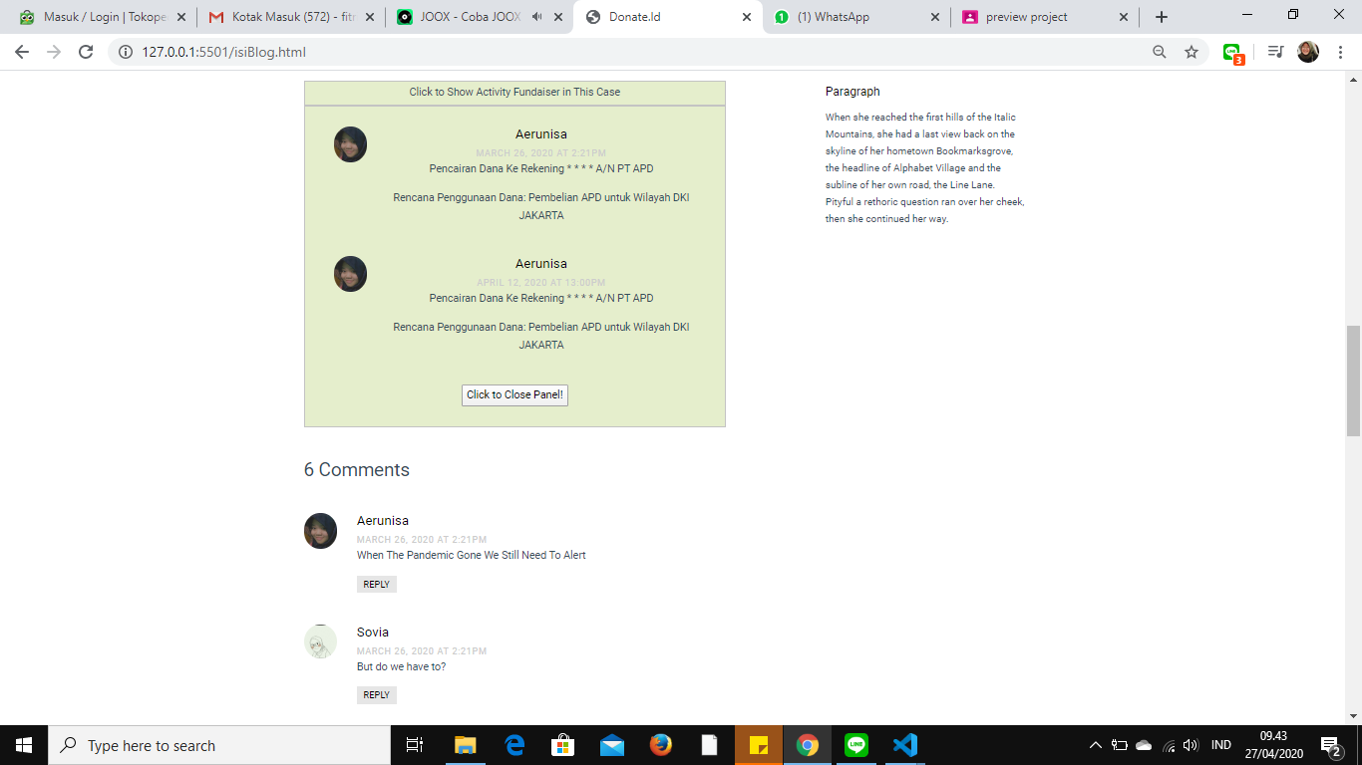

**IsiBlog Page**

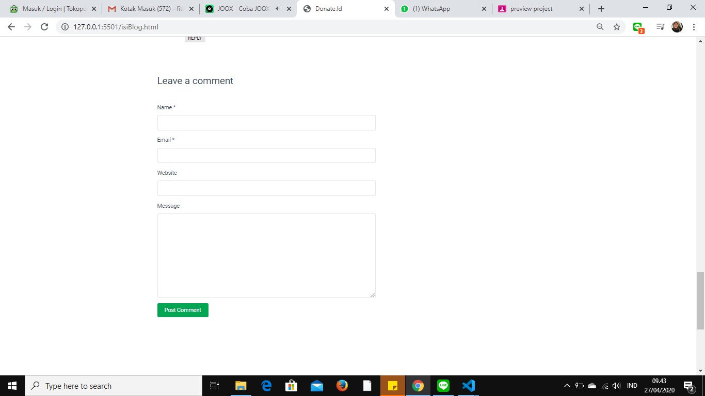

On the Blog Contents Page this certainly serves to inform the development of the case of donations such as, the current state of funds being disbursed etc.

**Contact Page**

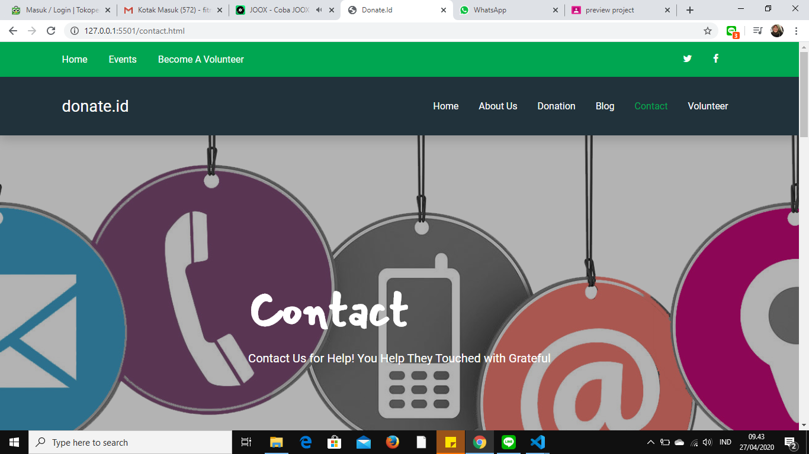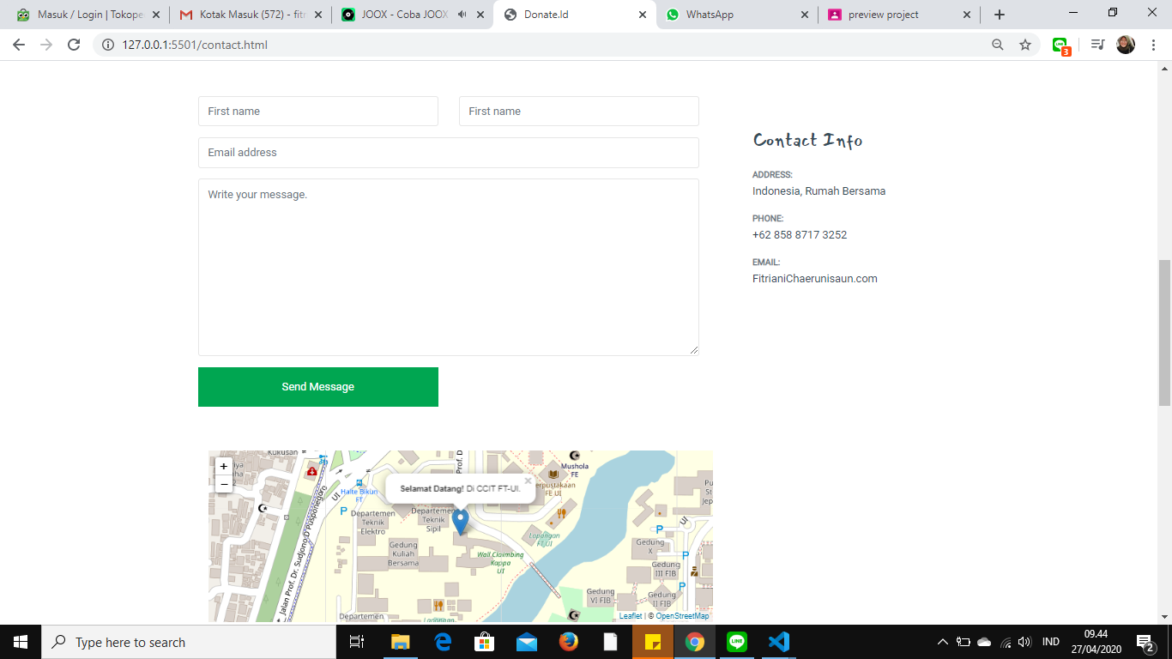

On the Contact Page it functions as a complaint or message service, here I use leaflets for location maps but I have not changed them then angular for the complaint form.

**Volunter Page**

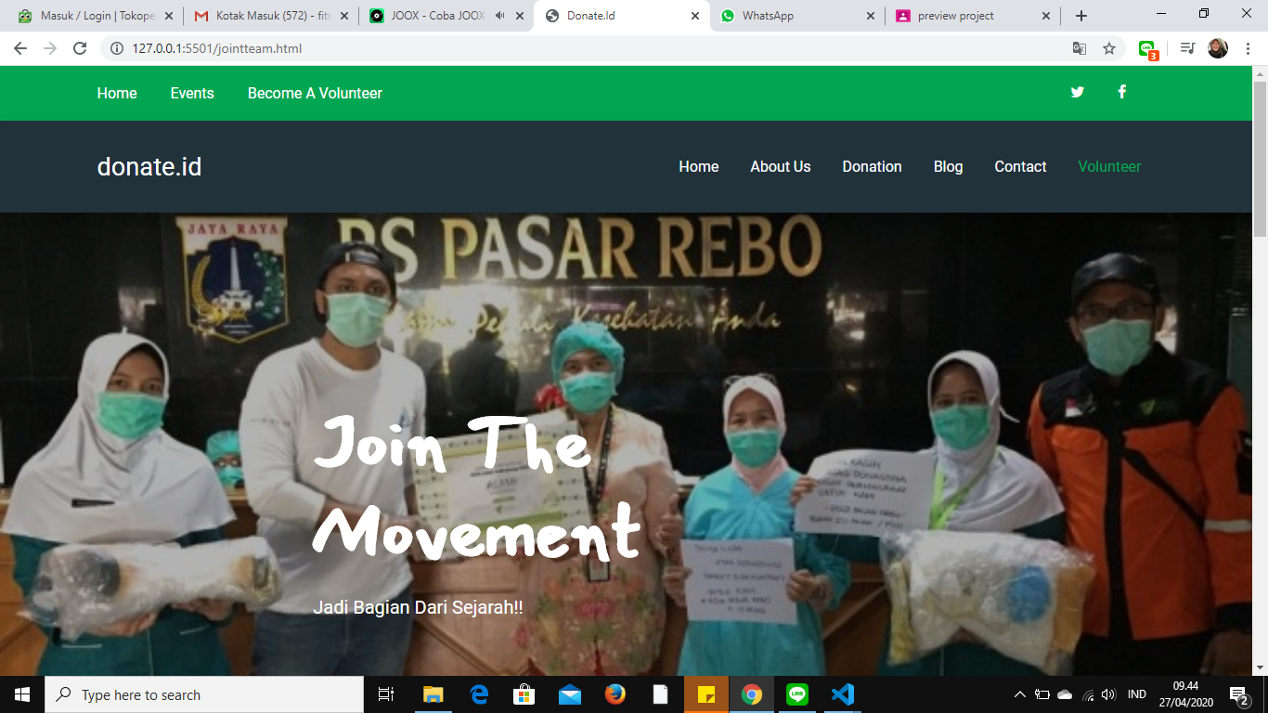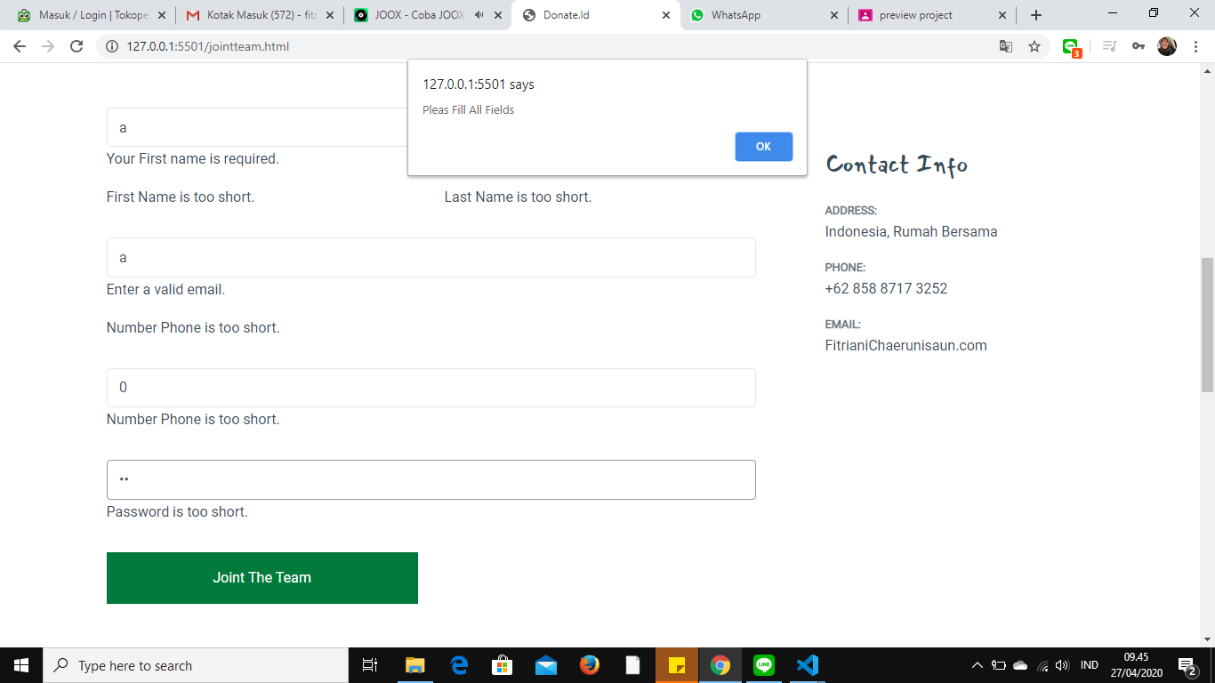

**Volunter Page**

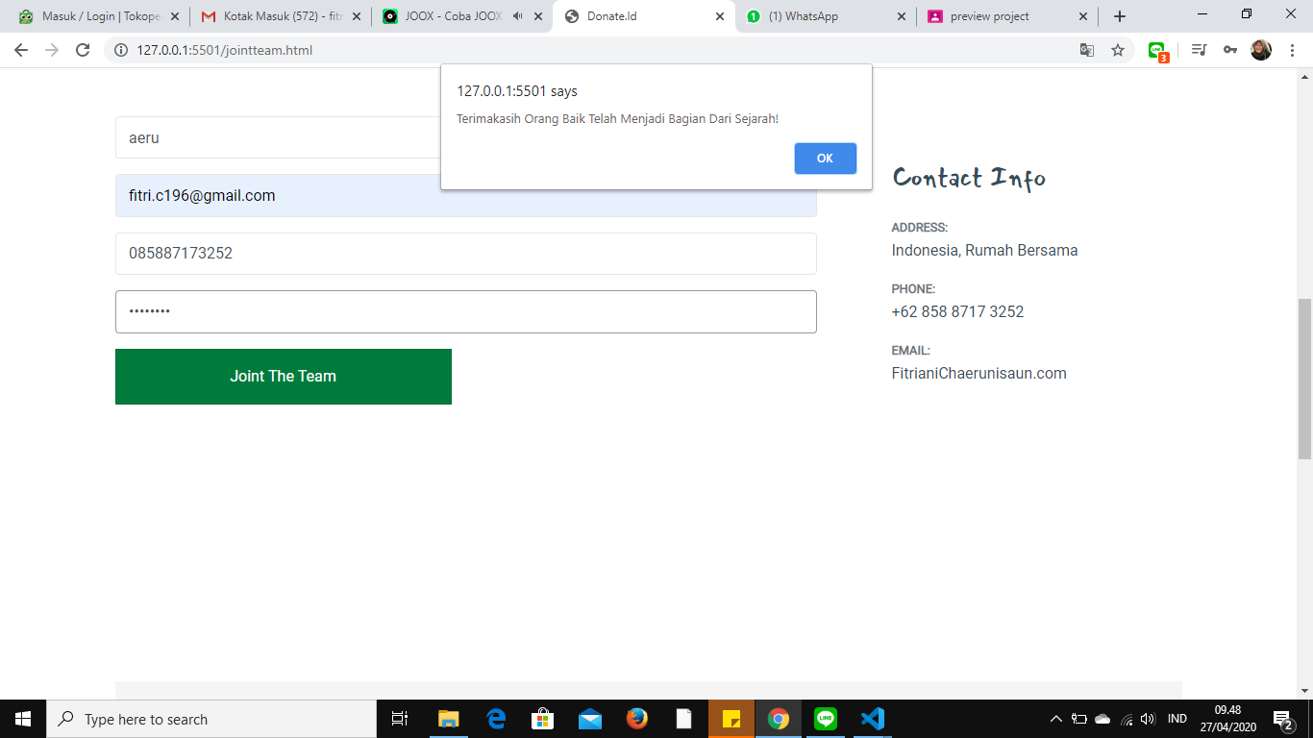

On the Volunter Page it functions to register as a fundraiser or open a fund, but it is still being developed for the open donation system. This page is still limited to registering.

**Donasi Page**

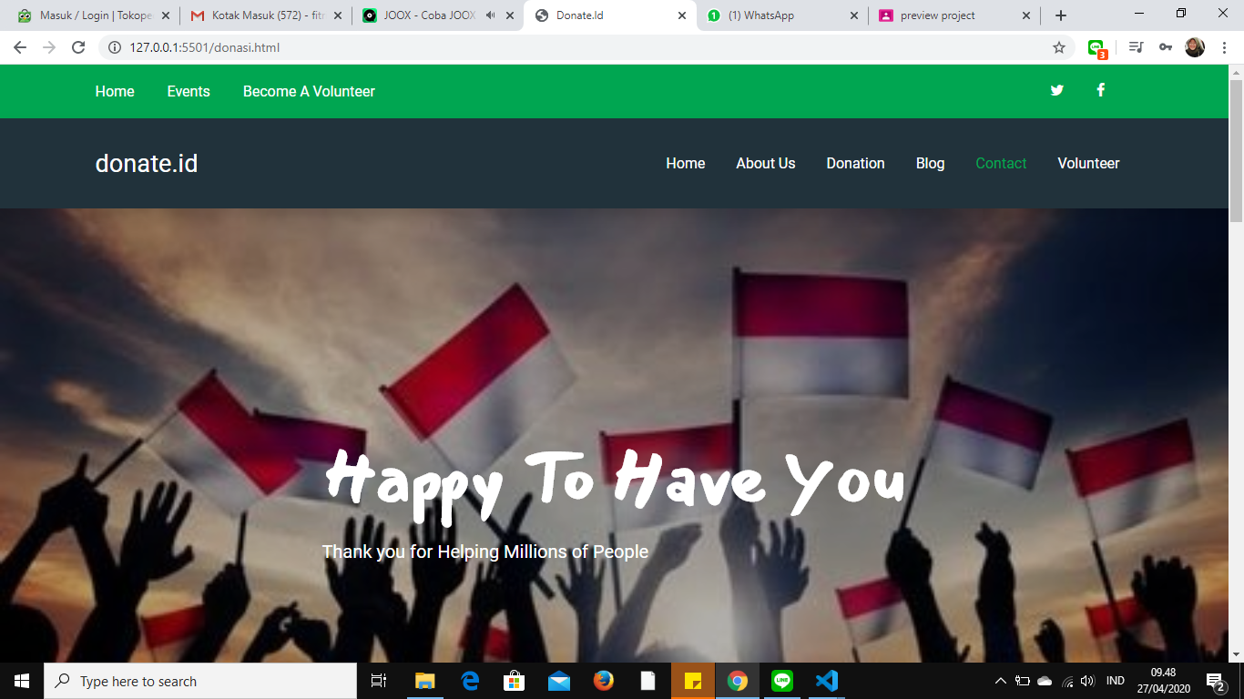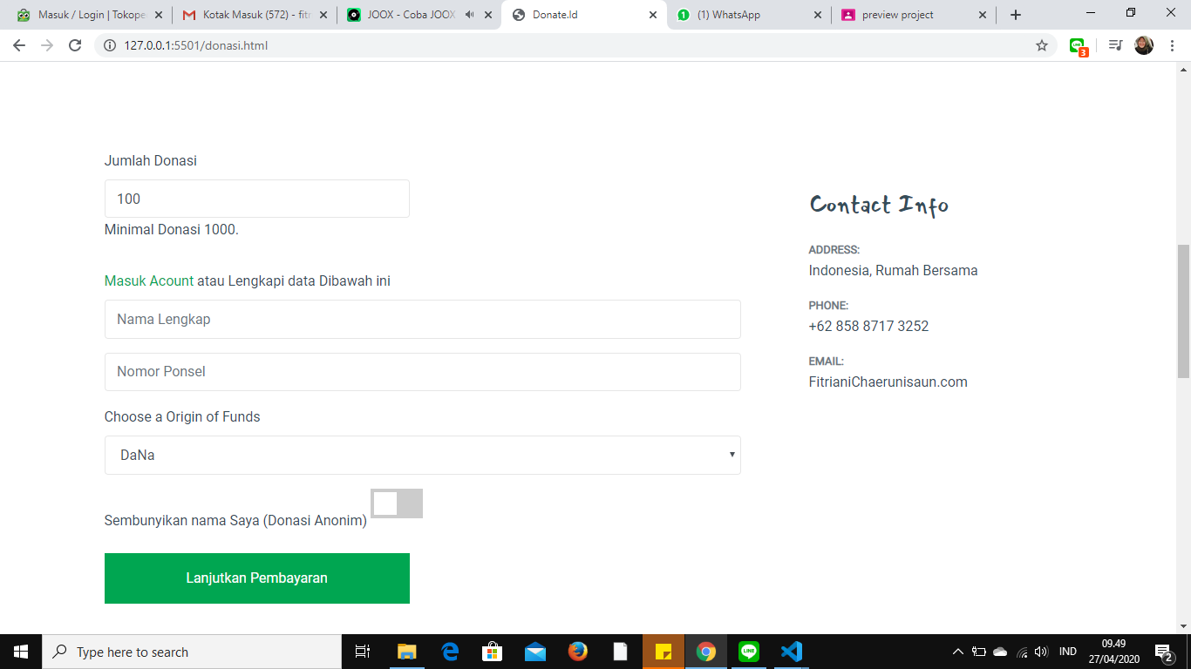

**Donasi Page**

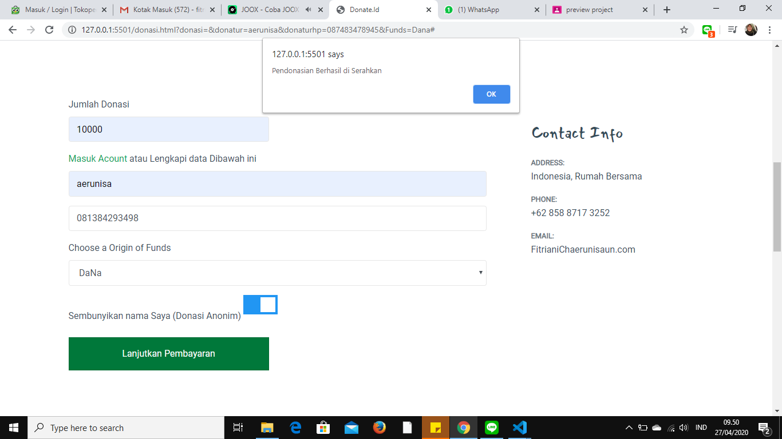

The donation page functions to donate

**Activity List**

|  |  |  |
| --- | --- | --- |
| **PROJECT FILE DETAILS** | | |
| **No** | **File Name** | **Remarks** |
| 1 | Home.html | Home Page |
| 2 | About.html | About Page |
| 3 | Blog.html | Blog Page |
| 4 | Contact.html | Contact Page |
| 5 | Donasi.html | Donasi Page |
| 6 | Isiblog.html | Isiblog Page |
| 7 | Jointteam.html | Jointteam Page |
| 8 | Jsondonation.html | Jsondonation Page |
| 9 | JSDonation.js | Javascript for Jsondonation.html |
| 10 | Donation.json | Contain data fo jsdonation |
| 11 | CSS.file | Contain file like boostrap, animation css |
| 12 | JS.file | Contain data like jquery, boostrap Javascript |

**CONFIGURATION**

Hardware : ASUS, i5- 3327U CPU@ 1,7GHz 8 GB Ram, 250 GB SSD

Operating System ; Windows 10

Software : Visual Studio, Microsoft Word 2016

**Project File Detail**

|  |  |  |
| --- | --- | --- |
| **No.** | **File Name** | **Remarks** |
| 1. | Escape | Contains all of the code for the program application |